UCD Copi-Print bureau in the John Henry Newman (Arts) building
Summer Opening Hours – Monday – Friday 1000 – 1600hrs daily - Not open on Bank Holidays
Staff are available to assist you with your printing queries during the above timings.
Printers & Desktops are available on a self-service basis outside these hours. With top-up available at the UCard Kiosks around campus.
Price List:
A4 Black & White @ 0.06c
A4 Colour @ 0.20c
A3 Black & White @ 0.12c
A3 Colour @ 0.40c
Printing accounts can be top up using the Kiosks around campus – only top up your account with what you need. Refunds cannot be processed for visitor accounts.
Residential Visitor Printing
If you are staying at UCD and would like to avail of our printing services, you can access our printing facilities using your room key or UCard. You can top up your UCard using one of our self-service kiosks located on campus.
The kiosks are at the following locations:-
- Beside the entrance to the UCard / Copi-Print bureau in the John Henry Newman (Arts) building
- James Joyce Library entrance (opposite the turnstiles beside the exit for the John Henry Newman [Arts] building)
- Richview Library
- Smurfit Business School Blackrock in the Oval room, Copi-Print area
Instructions for setting up your for topping up are given below
Approach the kiosk and follow the instruction " v HOLD UCARD TO UCARD READER BELOW v "
The UCard reader is directly below the screen, in the centre
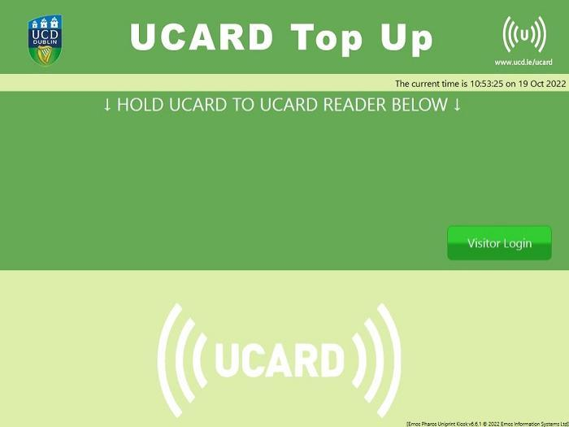
You will see your original UCard account balance
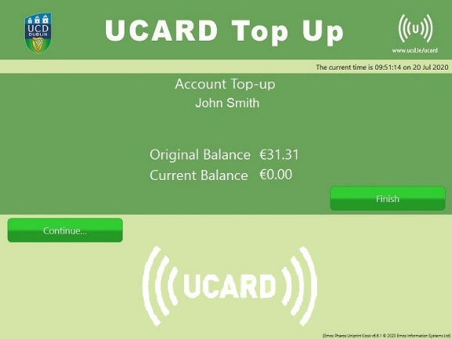
Choose "Continue..." on the display
Select the amount you wish to top up with
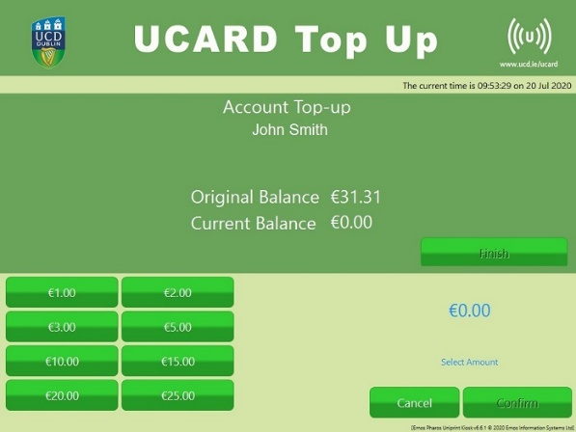
You will see the selected amount at the bottom-right of the display
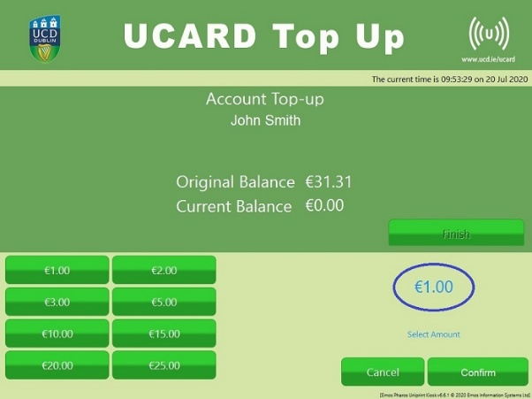
If you wish to top up with this amount, select Confirm
You will then be asked to follow the instructions on the Chip & PIN pad
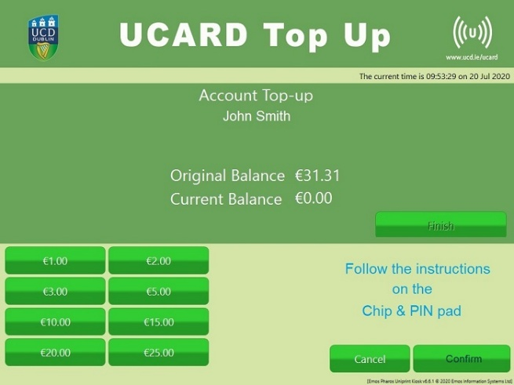
Tap your contactless payment card on the reader below the screen on the right-hand side. The reader will also accept Google Pay and Apple Pay options
The reader will confirm the amount topped up and the Current Balance on the display will reflect your new balance
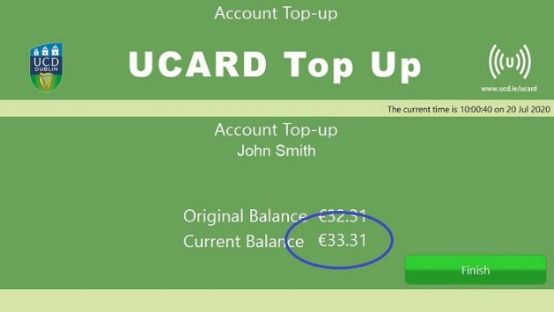
Press Finish on the display to log out

LOGGING INTO A PRINTER / COPIER WITH YOUR ACCOUNT
In order to print on campus as a visitor, you must use one of the desktops provided in the printing locations. It is advised to have your file saved on an email or a USB. In order to print the document, access the Copi Print desktop, and open the file. Go to print and select your preference for Black and white, Colour and A4 or A3 sizing. Once your document is ready, select print.
A window will pop up asking for your ID Number; this is the ID number linked to your visitor account. Input this number and select continue before approaching the printer.
- Approach the device you want to use
- Press "Swipe card or touch here to begin" on the display
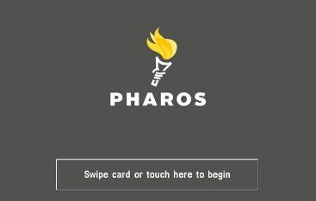
- Tap your card against the scanner on the device.

- You will now be able to use the device
- Press "logoff" or "exit" when you have finished

Non-Residential Visitor Printing
If you are visiting UCD and would like to avail of our printing services, you can set up a Visitor account using one of our self-service kiosks located on campus.
The kiosks are at the following locations:-
- Beside the entrance to the UCard / Copi-Print bureau in the John Henry Newman (Arts) building
- James Joyce Library entrance (opposite the turnstiles beside the exit for the John Henry Newman [Arts] building)
- Richview Library
- Smurfit Business School Blackrock in the Oval room, Copi-Print area
Instructions for setting up your Visitor account and for topping up are given below:

CREATING YOUR VISITOR ACCOUNT
- Approach the kiosk and choose the option "Visitor Login"
- Choose "Create"
- Read the 'Self Register' instructions. Press "Done" when you have read them
- You will see a User ID, which has been generated for you. Use the on-screen keyboard to fill out the remaining details
- When complete, select the options to e-mail and / or print the account details
- Select "Create"
- If you chose to print your account details, please take your ticket from the printer below the screen
- You can press "Continue..." on the screen to top up your account straight away or press "Finish" to log out

TOPPING UP YOUR VISITOR ACCOUNT
- Approach the kiosk and choose the option "Visitor Login"
- Enter your Visitor ID and Password
- Press "Login"
- You will see your original Visitor account balance
- Choose "Continue..." on the display
- Select the amount you wish to top up with
- You will see the selected amount at the bottom-right of the display
- If you wish to top up with this amount, select Confirm
- You will then be asked to follow the instructions on the Chip & PIN pad
- Tap your contactless payment card on the reader below the screen on the right-hand side. The reader will also accept Google Pay and Apple Pay options
- The reader will confirm the amount topped up and the Current Balance on the display will reflect your new balance
- Press Finish on the display to log out

SENDING A PRINT JOB
You can use any Copi-Print self-service computer to print documents
- Approach a Copi-Print PC
- Access the file you want to print via the web browser or from your USB drive
- Choose File -> Print in the application
- A popup window will appear:
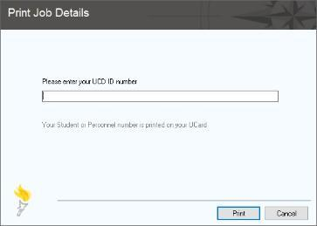
- Enter your Visitor account number
- Press Print
- Your print job will be sent

LOGGING INTO A PRINTER / COPIER WITH YOUR ACCOUNT
In order to print on campus as a visitor, you must use one of the desktops provided in the printing locations. It is advised to have your file saved on an email or a USB. In order to print the document, access the Copi Print desktop, and open the file. Go to print and select your preference for Black and white, Colour and A4 or A3 sizing. Once your document is ready, select print.
A window will pop up asking for your ID Number; this is the ID number linked to your visitor account. Input this number and select continue before approaching the printer.
- Approach the device you want to use
- Press "Swipe card or touch here to begin" on the display
- Enter your Visitor account number and press "OK"
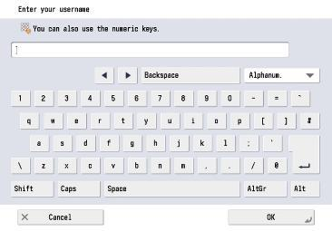
- Enter your password and press "OK"
- You will now be able to use the device
- Press "logoff" or "exit" when you have finished

